Urban Transformation Capacities
Joint Call for Proposals

Pre-Proposal: Consortium and General Information

- Project Overview
[General information will be inserted in the online submission system UDiManager at uefiscdi-direct.ro]
Project Short Title/Acronym:
Project Full Title:
Project Coordinator (Organisation + name of the PI):
Call topics: (tick the relevant call topic(s))
Topic 1: Urban circular economies
Topic 2: Community-based developments and urban innovation ecosystems
Topic 3: Robust and resilient urban infrastructure and built environment
Keyword 1:
Keyword 2:
Keyword 3:
Keyword 4:
Keyword 5:
Total Project Costs in EUR: |  | Requested funds in EUR:
Duration of the Project in months (max. 36): |  | Expected start: | [MM.YYYY]
Total Effort in Person Months: |  | Expected end: (MM.YYYY) | [MM.YYYY]

N.B.: Questions and comments in blue may be overwritten or deleted. Please stick to the following formatting requirements: font size: 10 pt, line spacing: 1.15. Both formatting requirements as well as the maximum number of pages (specified in the respective chapters) help the Expert Panel members to read and compare the proposals. Please note that you will be asked by the Call Secretariat to shorten your proposal after submission if the intended page limit is exceeded.
- Abstract
[Information will be inserted in the online submission system at uefiscdi-direct.ro]
Short presentation of project content and goals (max. 200 words). The abstract should make clear the project’s goals.

- Project Consortium
Please carefully choose the number of partners involved in the pre-proposal in the submission system – UdiManager
[Information will be inserted in the online submission system at uefiscdi-direct.ro]
e. g.:
 | Organisation | Type of organisation | Country / Funding agency | Contact Person (first name and family name)
Project Coordinator/Main Applicant
Project Partner 2
Project Partner 3
Project Partner 4
Project Partner 5
- Financial Information
This section is dedicated to the budget planning for your project. Please carefully check all the information introduced and press the “Save” button after introducing data for each applicant, to make sure your final financial data is correctly displayed.
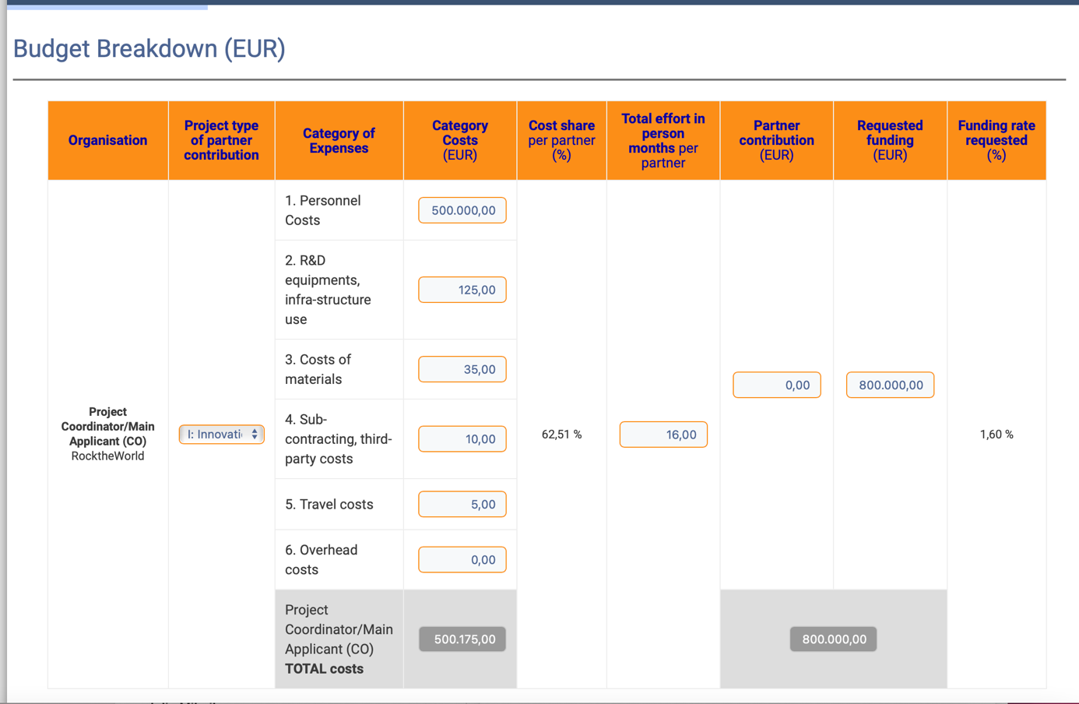

4. Quality of Work, Project Objectives and Targets (max. 2 pages)
[Information will be inserted in the online submission system at uefiscdi-direct.ro]
One document must be uploaded imperatively as an unprotected PDF file (document generated from a word processor file to a PDF, no scanned document).
Please stick to the following formatting requirements: font size: 10 pt, line spacing: 1.15. Both formatting requirements as well as the maximum number of pages (specified in the respective chapters) help the Expert Panel members to read and compare the proposals. Please note that you will be asked by the Call Secretariat to shorten your proposal after submission if the intended page limit is exceeded.

4.1 Project objectives and targets
Projects should study transformation processes and transformative capacity building for increased knowledge and understanding of such processes making it possible to develop this knowledge further. Projects are encouraged to use new technologies and tools for implementation of research and innovation and to ensure possibilities for scaling up.
Comprehensibly describe the approaches you intend to use to achieve the defined goals and expected results.

4.2 Overall project type
This call welcomes a broad range of research and innovation projects that enable capacity building for urban transformations.
Projects should clearly build upon previous experiences of building capacity in practice and build upon existing knowledge of transformation capacities towards urban sustainability, resilience and liveability.
All projects are expected to be cross-sectoral and will be required to clearly engage relevant stakeholders, including the public sector, private sector, civil society and academia, throughout the duration of projects. Projects must also have a transdisciplinary approach, including relevant disciplines, such as natural sciences, social sciences, technical sciences, and applied fields, to support and implement integrative approaches and strategies to enhance urban transformation capacities.
5. Key activities (work programme – max. 1 ½ pages)
Describe the contents of the envisioned work programme, the results expected within the duration of the project and the main milestones.

6. Data Management (max. ½ page)
Provide a brief outline of the data management strategy you plan to implement within your project (see also Annex C of the call text).

7. Added value of international co-operation (max. ½ page)
Describe the added value of the planned international co-operation with regard to the objectives of your project.

8. Relevance – Contribution of the project to the goals of the call (max. ½ page)
Describe how and to what extent the project addresses the chosen call topic(s). Furthermore, describe how the project contributes to the objectives of the call.

9. Impact of the project (max. ½ page)
Describe the extent to which the project is likely to be a value to potential user communities (e.g. public sector, private sector, civil society and academia OR urban government authorities, research organisations, companies and commercial organisations, consumers, civil society etc.)

10. Project consortium, trans-disciplinary, collaboration multi-actor involvement, co-creation (max. 1 page)
Describe how your proposal addresses, as a consortium, all scientific, technical and organisational competences required to implement the project.
All projects are expected to be cross-sectoral and will be required to clearly engage relevant stakeholders, including the public sector, private sector, civil society and academia, throughout the duration of projects. Projects must also have a transdisciplinary approach, including relevant disciplines, such as natural sciences, social sciences, technical sciences, and applied fields, to support and implement integrative approaches and strategies to enhance urban transformation capacities.

11. References (max. 1 page)
Add relevant references.

Detailed financial information must be given in the Financial Information section on uefiscdi-direct.ro
Type of organisations: University or Other Educational Institution; Public or Private Research Organisation, Business – SME; Business – Large Enterprise City Authority/Municipality; Other Public/Governmental Institution *Special Interest Group **Other Non-Profit Organisation * Other Public/Governmental Institution: e.g. hospital, other public utility, public infrastructure company; ** Special Interest Group: e.g. union, chamber. Note: With regard to the size of companies, for all EU member states the current definitions of SMEs given in the EU competition law are applied (definition of small and medium-sized enterprises and of independent businesses in accordance with recommendation 2003/361/EC of the Commission dated 6 May 2003, [ABl. L 124 of 20.5.2003, pp. 36-41]; cf. https://ec.europa.eu/growth/smes/sme-definition_en).
Consortium partners from Belgium must name their respective funding agency/agencies.
“Project Partner” in this table means a Co-Applicant or a Co-operation Partner (see chapter 3 of the call text).

