ERA-NET Cofund on Urban Accessibility and Connectivity

https://jpi-urbaneurope.eu/calls/enuac-knowledge-hub/

Knowledge Hub Call 2022
ELECTRONIC SUBMISSION SYSTEM

GUIDELINES FOR APPLICANTS

Aurélien Gaufrès
aurelien.gaufres@anr.fr
+33 1 73 54 82 29

Table of contents
1. Introduction 3
1.1. About your Expression of Interest (EoI) 3
1.2. About the submission system 3
1.3. Roles in the submission process 3
2. How to connect? 4
2.1. Submission website 4
2.2. Create an account 4
2.3. Activation of your account 5
2.4. Authentication page 6
2.5. User role 6
3. How to create your EoI? 7
3.1. Submit an EoI 7
3.2. Identification of the project 7
3.3. Information about your submission 9
3.3.1. Partnership and tasks 10
3.3.2. Partners/Organisations files 10
3.3.3. Identity of the Project 12
3.3.4. Scientific Abstracts 12
3.3.5. Scientific Document 13
3.3.6. Submission of the project 13

Introduction

About your Expression of Interest (EoI)
All documentation related to the call is provided on the following EN-UAC website page: https://jpi-urbaneurope.eu/calls/enuac-knowledge-hub/.
Prior to submitting on the electronic submission system, the main applicant must carefully read the call announcement and prepare the Expression of Interest (EoI) document and letter, to be submitted in PDF format, using the templates available on the call page.

Keep in mind that each national funding organisation has its own funding criteria and regulations, which are provided in the call announcement.

About the submission system
The EN-UAC Knowledge Hub Call 2022 electronic submission will be hosted on the French National Research Agency (ANR) electronic submission platform (https://aap.agencerecherche.fr/). The present document is designed to guide applicants through the submission process and ensure a smooth submission.
Please note that some features of the submission platform are not used for this call and therefore some fields in the interface can be ignored. For example, financial information is not required for the EoI submission, as it will not considered yet at this stage of the call.
Each page where changes are made on the submission platform must be saved (using the “Save” button) before going to another page.

Roles in the submission process
The application process is started on the system by the main applicant. On the system this individual may be referred to as the “Project coordinator”, even though the EN-UAC Knowledge Hub call does not require the submission of a project proposal.
The main applicant is automatically informed by email once they have begun a submission. The email invites them to log into the system in order to complete, check or modify the information about the EoI. It is the responsibility of the main applicant to ensure that they have properly filled in all the required information. When the EoI is complete, the main applicant can lock it for submission.

How to connect?
The main applicant can get access to the website which hosts the electronic submission system in the following way.

Submission website
The electronic submission system is available at the following URL: https://aap.agencerecherche.fr/_layouts/15/SIM/Pages/SIMNouveauProjet.aspx?idAAP=1776
NOTE: The user interface is bilingual (French and English). Click on the flag on the upper-right side of the screen to reach the pages in English. The main applicant can change the interface language at any time.

Create an account
The welcome page of the submission system is shown below. Fill in the form with the main applicant’s personal information (Last name, First name, Email address).
If the main applicant already has an account on the ANR submission website, they can directly go to the authentication page.
If the applicant has forgotten their password, a new one can be requested on the authentication page.
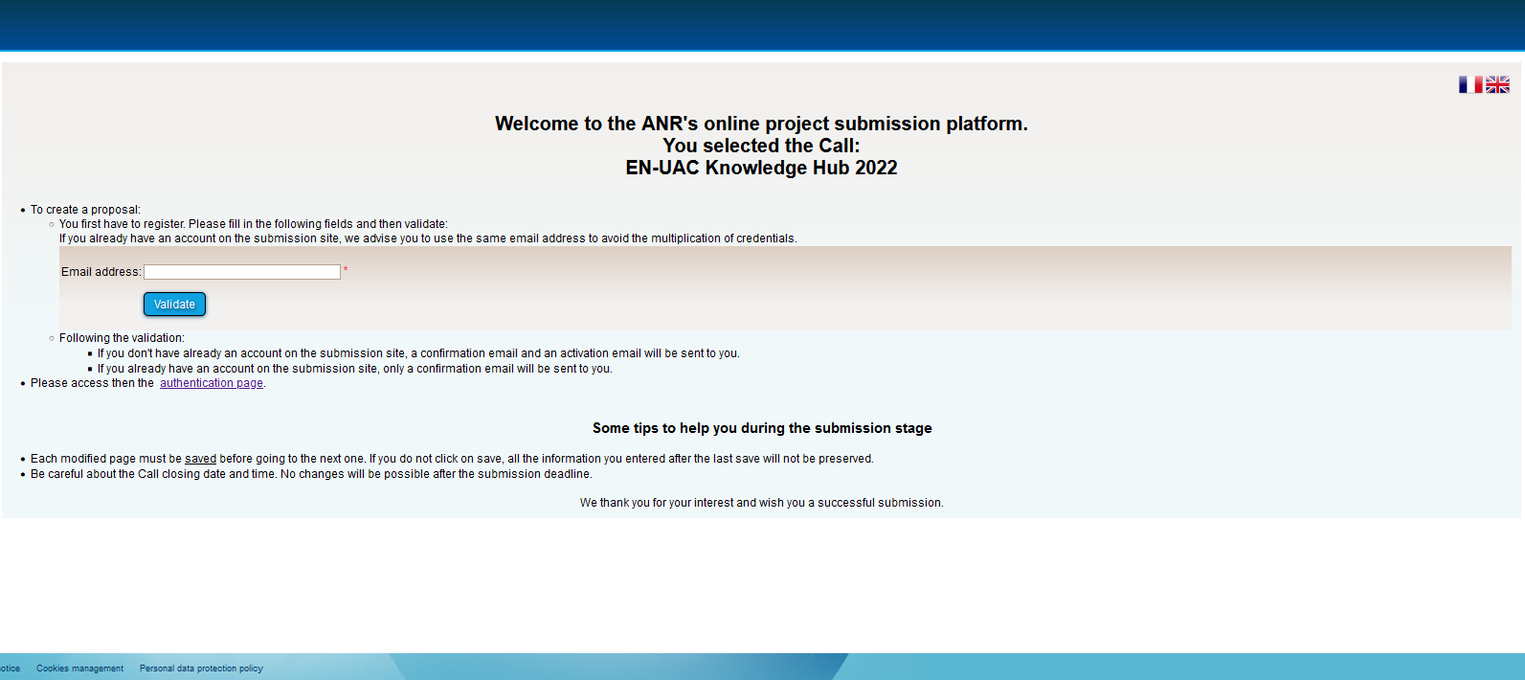
If you already have an account on the ANR submission website, you can directly access the “Authentication Page”.

Activation of your account
If the applicant is a new account holder, an activation email will be sent from the website in the following format (if the email is not received, the spam inbox should be checked):
FROM: SIM ANR simnoreply@agencerecherche.fr
SUBJECT: Activation de votre compte / Account Activation
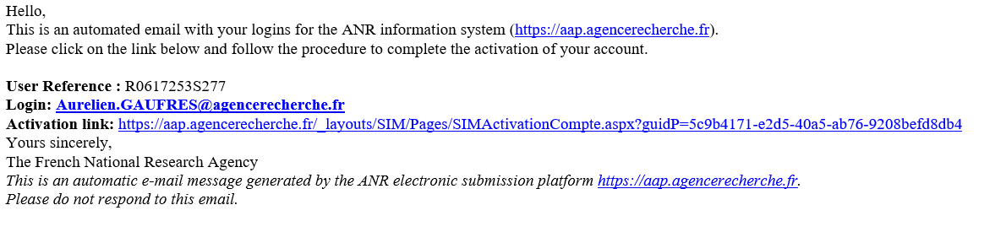The activation link from the email should be opened and the account then activated.
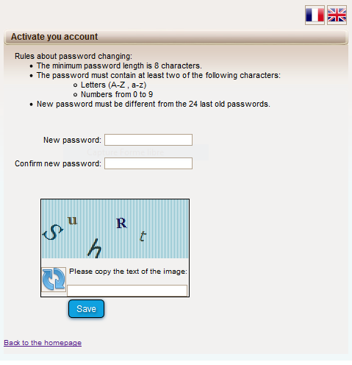

Authentication page
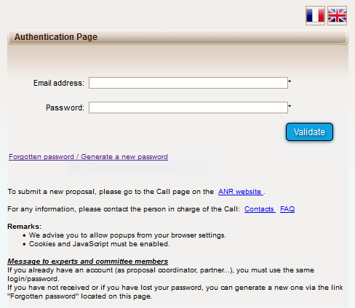
If you have forgotten your password, you can provide your e-mail address here to get a new one.
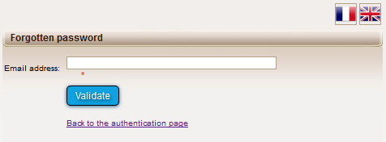
Insert your e-mail address
Insert password

User role
After validation, the system will ask the applicant to choose their user profile. Please select: Project Coordinator (can modify all the information).
To create a new submission, select “Project Coordinator” and click on the “Access” button.

How to create your EoI?

Submit an EoI
NOTE2: The terms “proposal” and “project” are used interchangeably throughout the submission process on the system. For the purposes of the EN-UAC Knowledge Hub call, the terms “proposal” and “project” are to be understood as “Expression of Interest”, as this submission is a call for EoIs. As already mentioned, the term “coordinator” refers here to the main applicant of the EoI.
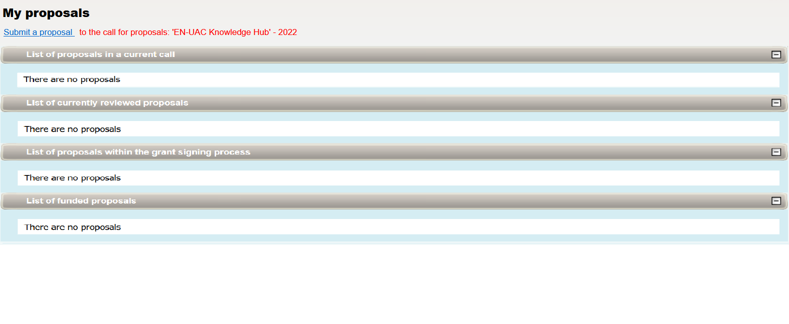

Identification of the project
The title request for the EoI is a default setting on the system, as usually the system is used for project proposals. Although it is not a mandatory requirement in the EoI template, please complete the title section with the main applicant’s name (as demonstrated in the screenshot below) which will help the funders with the management of the submissions received.
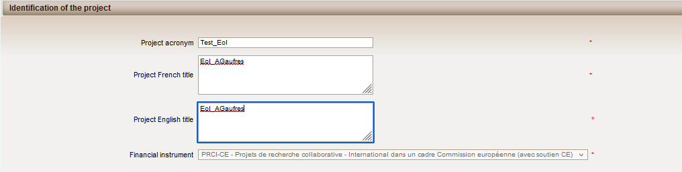
You do not need to translate the title in French. You can simply copy and paste the English title here.

On the same page, as the main applicant of the EoI, the following form will also need to be completed:
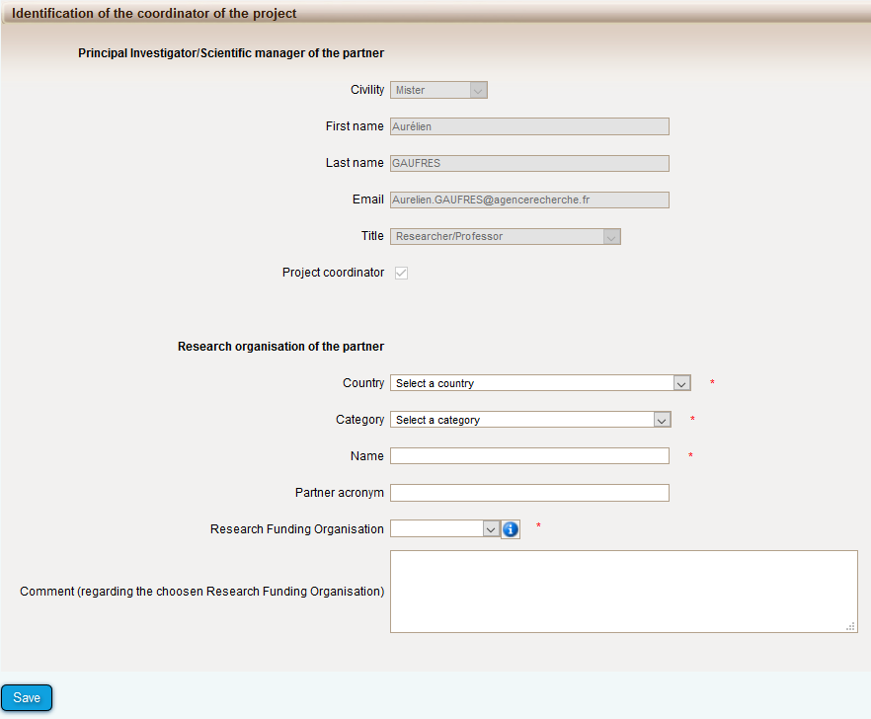
Select the category which best describes your organisation from the following choices:
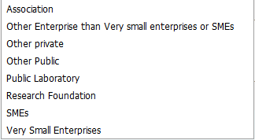
NOTE3:
This list is based on the French terminology of research and innovation bodies. In France, universities are referred to as public bodies, or a “Public Laboratory”, where a facility in a university or faculty receives public funds in order to conduct scientific or technological research, experiments or measurements in controlled conditions.
If the applicant works within a university that receives public funding to conduct research, the category “Public laboratory” should be chosen. If the applicant works within a university that primarily uses private funds to conduct research, the category “Other private” should be chosen.

The list of possible funding organisations is based on the countries and organisations involved in this call. Please firstly select the country within which the main applicant is based.
The options noted below for each country will then appear. By selecting a funding organisation, the applicant is indicating that they wish to apply for funding from that organisation for their involvement in the EN-UAC Knowledge Hub.
- Austria: “FFG”
- Latvia: “IZM”
- Sweden: “Formas”
- United Kingdom of Great Britain and Northern Ireland (the): “ESRC”
- France: “ANR”.

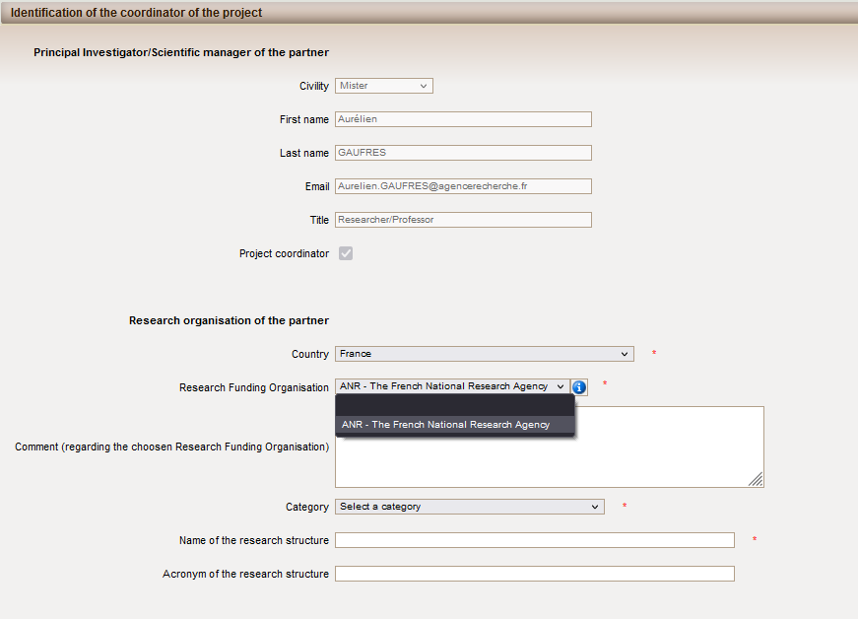

NOTE 4
According to the eligibility rule stated in the call announcement, this is not possible to select a funding organisation (mandatory field) when a non-participating country is chosen. There is no possible option “With own funding” for any country chosen.

Information about your submission
Once the EoI identification information has been provided, access will be given to the main online submission page composed of several tabs where the main applicant will need to fill in all the information needed for the evaluation of the EoI (from the left to the right side of the screen):
- Partnership and tasks
- Partners/Organisations files
- Identity of the Project
- Scientific Abstract
- Scientific Document
- Submission of the project
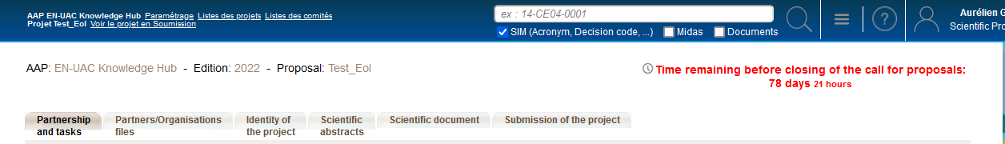

Partnership and tasks
Under this tab, the main applicant can modify basic information about themselves as an applicant and their organisation. As stated in the call announcement, “each expert/entity needs to submit a separate EoI”. Therefore, additional partners should not be added to form a consortium at this stage of the process.
Modify your information

Partners/Organisations files
This tab enables the applicant to provide further information. It contains two sub-tabs: “Administrative data” and “Financial data”.
The “Administrative data” sub-tab includes the following:
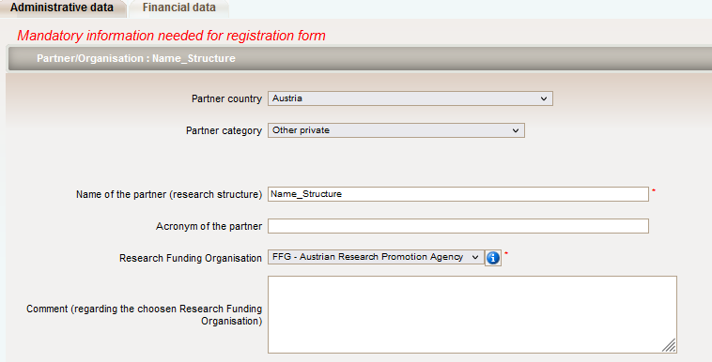
The applicant should check the category of their organisation.
In the page shown below, the main applicant can provide additional optional information about themselves.
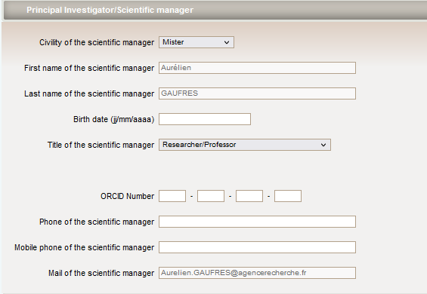
It is possible to add other individuals that are involved in the wider team of the main applicant, should they be applying as an institute/team to the EoI.
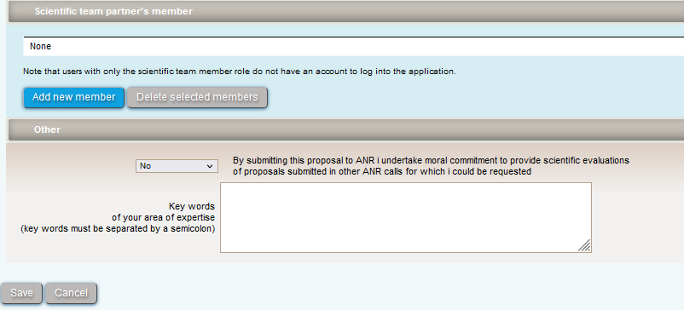
The “Financial data” sub-tab is a default setting of the submission system and information should not be added here at this stage.

Identity of the Project
Under this tab general information about the EoI is to be included. The duration of the project, i.e. duration of the envisaged involvement into the Knowledge Hub as a member, should be entered as 24 months since the EN-UAC pilot Knowledge Hub is planned to run for two years.
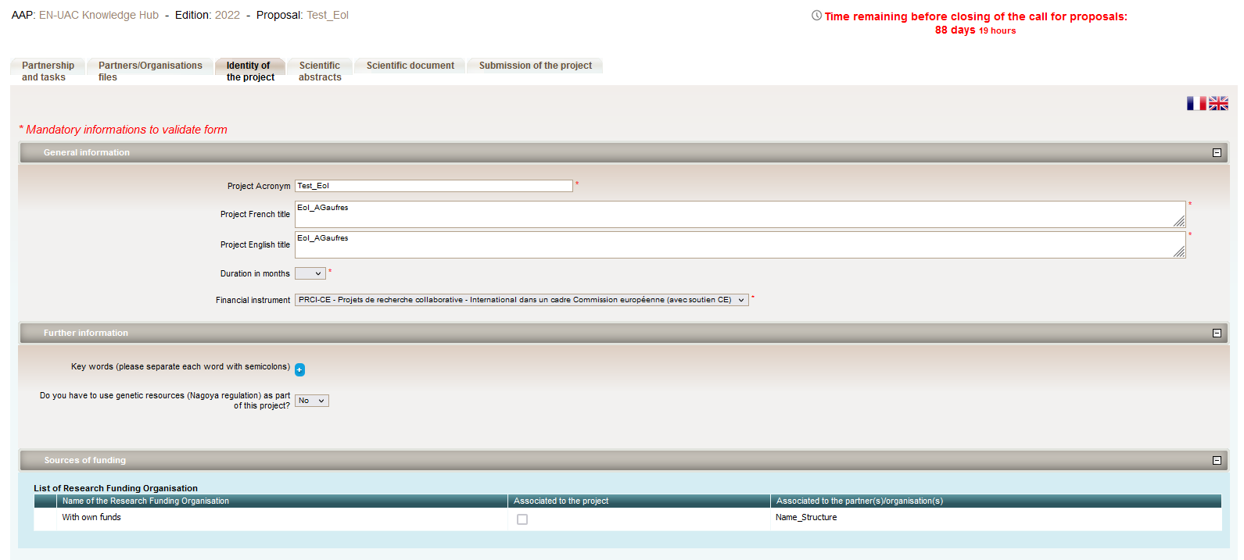

Scientific Abstracts
This tab is a default setting of the submission system, where applicants usually include the scientific abstract of a project proposal. For this call, applicants should provide the applicant contribution information which is also included in section 4 of the EoI document.

Scientific Document
Within this tab the EoI document using the EoI template provided on the call website and the EoI letter which confirms your organisation supports your submission to this call must be uploaded. Both documents must be submitted in PDF format.
Each main applicant must submit an EoI document (i.e. scientific document) using the template available on the EN-UAC website: link
Each main applicant must submit an EoI letter (i.e. annex to the scientific document) using the template available on the EN-UAC website: link
Upload the EoI letter in PDF format.
Upload the EoI document in PDF format.
As specified in the call announcement, the EoI document must be written in English.

Submission of the project
This tab enables the main applicant to lock and unlock the EoI. It also provides information on the EoI validity. Alerts shown in red indicate that mandatory information or attachments are missing that mean the submission cannot be submitted.
A confirmation email is sent to the main applicant once the call is closed.

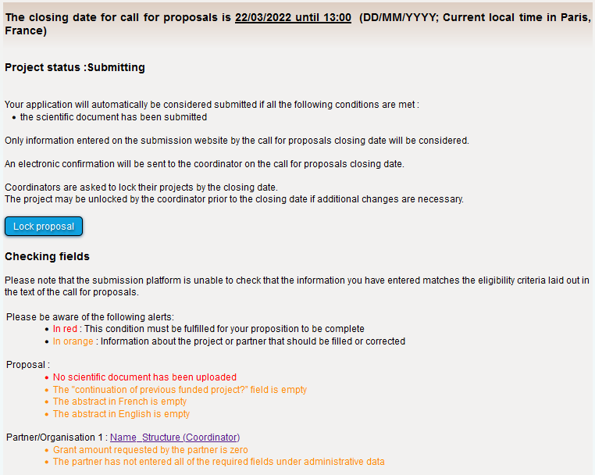

https://jpi-urbaneurope.eu/calls/enuac-knowledge-hub/

