Joint Call for Proposals
for research and innovation projects on

Building transformation capacity through arts and design: Unlocking the full potential for urban transitions

A Joint Call within the European Union’s Horizon 2020 research and innovation programme ERA-NET Cofund Urban Transformation Capacities (ENUTC) under Grant Agreement No. 101003758

Proposal: Consortium and General Information

Project Overview
[General information will be inserted in the online submission system UDiManager at uefiscdi-direct.ro]
Project Short Title/Acronym:
Project Full Title:
Project Coordinator/Main Applicant (Organisation + name of the PI):
Call topics: (tick the relevant call topic(s))
Topic 1: Experimentation and co-creation for a beautiful and sustainable urban future
Topic 2: Transformation to sustainable cities / urban transformation
Topic 3: Designing Inclusive, Liveable and Green Neighbourhoods
Keyword 1:
Keyword 2:
Keyword 3:
Total project costs in EUR: |  | Requested funds in EUR:
Duration of the project in months (max. 24): |  | Expected start: | [MM.YYYY]
Total effort in person months: |  | Expected end: | [MM.YYYY]

N.B.: Questions and comments in blue may be overwritten or deleted. Please stick to the following formatting requirements: font size: 10 pt, line spacing: 1.15. Both formatting requirements as well as the maximum number of pages (specified in the respective chapters) help the Expert Panel members to read and compare the proposals. Please note that you will be asked by the Call Secretariat to shorten your proposal after submission if the intended page limit is exceeded.

Abstract
[Information will be inserted in the online submission system at uefiscdi-direct.ro]
Short presentation of project content and aims (max. 200 words). The abstract should make clear the project’s aims.

Project Consortium
Please carefully choose the number of partners involved in the pre-proposal in the submission system – UDiManager
[Information will be inserted in the online submission system at uefiscdi-direct.ro]
 | Organisation | Type of organisation | Country / Funding agency | Contact Person (first name and family name)
Project Coordinator/Main Applicant
Project Partner 2
Project Partner 3
Project Partner 4
Project Partner 5
Please insert additional rows if necessary: place cursor in last row and select “Table insert row below” from the menu bar.

Quality of Work, Project Objectives and Targets (max. 4 pages)
[Information will be uploaded in the online submission system at uefiscdi-direct.ro]

Project aims, objectives and targets, positioning with respect to the state of the art, existing knowledge or solutions and other recently completed or on-going comparable projects
Give a detailed description of the project aims, objectives, targets and planned results based on the description of the initial situation and the societal/ social, economic, environmental, or technological problems and challenges related to the call topic(s) and to be solved in the project. Specifically go into the need for the solution, e.g. what is the need for city management or what are the needs for the citizens?
Clearly point out the innovative aspect in your approach taking into account the state of the art/knowledge (improvements from existing solutions/conditions, originality of approach, degree of novelty, technological leap). Indicate how it is positioned with respect to the state of the art and, how it builds on and complements existing knowledge and experiences as achieved in earlier relevant European, national and regional research and innovation (R&I) programmes, pilots and test implementations and field labs.

Project realisation
Describe how the project proposes to tackle the above mentioned topic(s). Comprehensibly describe the conceptual (scientific and/or technical) approaches you intend to use to achieve the defined goals and expected results.

Overall project type: research and innovation aspects in relation to the project topic(s)
Please describe the main reasons for the selected overall project topic(s).

Consortium experience and complementary with other projects of the partners
Please explain the differences and complementarity to max. 5 other projects carried out by the consortium partners in the past three years. Include in particular all ongoing and completed projects of thematic relevance. Special focus should be placed on the results you intend to use for your project and potential synergies.
Use the following table to provide the relevant information:
Table 4.1: Existing results and deliverables obtained from publicly funded projects which provide the basis of or feed into the proposed project
Funding provider | Project number | Title | Description of results already obtained and relevant deliverables (verifiable results / products of research, development and innovation work) in terms of the basis for / differentiation from the proposed project | Location and type of documentation  (e.g. link to homepage, publication, conference proceedings, interim report, final report, …)

Added value of international cooperation (max. 1 page)
Describe the added value of the planned international cooperation with regard to the objectives of your project.

Key activities and work programme description
A detailed work plan should be presented, broken down into work packages (WPs) which should follow the logical phases of the implementation of the project, and include consortium management and assessment of progress and results .
Please present your plans as follows:
i) Describe the overall strategy of the work plan (max. 1 page)
ii) Show the timing of the different WPs and their components (Gantt chart or similar)
iii) Provide a detailed work description broken down into work packages:
    - Work package list (please use table 7.1)
    - Deliverables list (please use table 7.2)
    - List of milestones (please use table 7.3)
    - Description of each work package (please use table 7.4, max. 1 page per work package)
iv) Describe any significant risks, and associated contingency plans (max. 1 page)
    - Note: The number of work packages used must be appropriate to the complexity of the work and the overall value of the proposed project. The planning should be sufficiently detailed to justify the proposed effort and allow progress monitoring.

Use Tables 7.1, 7.2, 7.3, 7.4 provided in the proposal template available on the webpage of the call.

Table 7.1: Work package list
Work package  No | Work package title | Lead  project partner  No | Lead project partner short name | Person-months | Start  month | End  month
 |  | TOTAL

Table 7.2: Deliverables List
Del. no. | Deliverable name | WP no. | Delivery date

Table 7.3: List of milestones
Milestones are control points where decisions are needed with regard to the next stage of the project. For example, a milestone may occur when a major result has been achieved, if its successful attainment is required for the next phase of work.
Milestone number | Milestone name | Work package(s) involved | Expected date

Table 7.4: Work package description (max. 1 page per work package)
For each work package:

Work package number |  |  | Start date or starting event:
Work package title
Project partner number
Project partner short name
Person months per applicant:
Objectives

Description of work (possibly broken down into tasks) and role of applicants

Deliverables (brief description and month of delivery)

Ethical and regulatory considerations (max. ½ page)
If relevant, please describe possible ethical and/or regulatory issues and considerations including authorisation requirements (scientific ethics, data security and use of laboratory animals or other) and handling of health, environmental or ethical issues associated with the project. If relevant, you can refer to (or elaborate in) the data management section.

Relevance – Contribution of the project to the aims and expectations of the call (max. 1 page)
Describe how and to what extent the project addresses the chosen call topic(s). Furthermore, describe how the project contributes to the aims and expectations of the call.

Diversity Aspects (including gender dimension) or specific populations’ consideration (max. 1 page)
Describe the ways in which gender and other diversity perspectives (age, ethnicity, and nationality) are relevant to the project content. Also describe the diversity of the project consortium.

Impact of the project (max. 2 pages)

Expected impacts
Give a detailed description of how the sustainability of the solution after the project finalisation is foreseen and what the societal/ social, economic, environmental, or technological impact is expected to be. Describe the extent to which the project is likely to be of value to potential user communities (e.g.: governmental or non-governmental organisations, communities, private companies, inhabitants, end users, other relevant stakeholders like local transport authorities, etc.). How do you estimate the potential market for the project results? Where this is of relevance to the research project and its implementation: Will the project have an impact with broader geographical spread over the globe?

Dissemination and/or exploitation of project results and management of intellectual property
Describe the measures you propose for the dissemination and/or exploitation of project results, and how these will increase the impact of the project. In designing these measures, you should take into account a variety of communication means and target groups as appropriate (e.g. policymakers, interest groups, media and the public at large).
Describe also your plans for the management of knowledge (intellectual property) acquired in the course of the project.
10.3. Data Management (max. ½ page)
Provide a brief outline of the data management strategy you plan to implement within your project (see also Annex B of the call text).

Project consortium, transdisciplinary, collaboration multi-actor involvement, co-creation

Consortium resources (max. 1 page)
Describe how the project partners collectively constitute a consortium capable of achieving the project objectives, and how they are suited and are committed to the tasks assigned to them. Show the complementarity between project partners. Explain how the composition of the consortium is well-balanced in relation to the objectives of the project. Describe the approach of your proposal according to multi-actor involvement and transdisciplinary collaboration (including the integration across the natural sciences, social sciences, technical sciences (engineering and computer sciences), and applied fields such as transportation planning, logistics, traffic engineering, urban and spatial planning and policy development, architecture, design, as well as artistic and creative disciplines) and co-creation.
If appropriate, describe the industrial/commercial/societal involvement to ensure exploitation of the results, and how the opportunity and requirement of of involving urban government authorities has been addressed.
A written commitment (Letter of Intent) from Cooperation Partners, participating with their own funding or with an in-kind contribution must be submitted with the full proposal.

Management structure and procedures (max. 1 page)
Describe the organisational structure and decision making mechanisms of the project. Show how they are matched to the complexity and scale of the project.

Individual project partners
For each partner in the proposed project, provide a brief description of the legal entity, the main tasks they have been attributed, and the previous experience relevant to those tasks (including brief CV and main publications). If applicable, include a description of previous work with cities, urban government authorities and other relevant stakeholders. Provide also a short profile of the staff members who will be undertaking the work. Maximum length one page per project partner. However, where two or more departments within an organisation have quite distinct roles within the proposal, one page per department is acceptable. The maximum length applying to a legal entity composed of several members, each of which is a separate legal entity, is one page per member, provided that the members have quite distinct roles within the proposal.)
Please also include the Cooperation Partners in this part.
Subcontracting: If any part of the work is to be subcontracted by the applicants responsible for it, describe the work involved and explain why a subcontract approach has been chosen for it.

- Financial information (budget breakdown)

Please fill in the information on uefiscdi-direct.ro. This section is dedicated to the budget planning for your project. Please carefully check all the information introduced and press the “Save” button after introducing data for each applicant, to make sure your final financial data is correctly displayed.
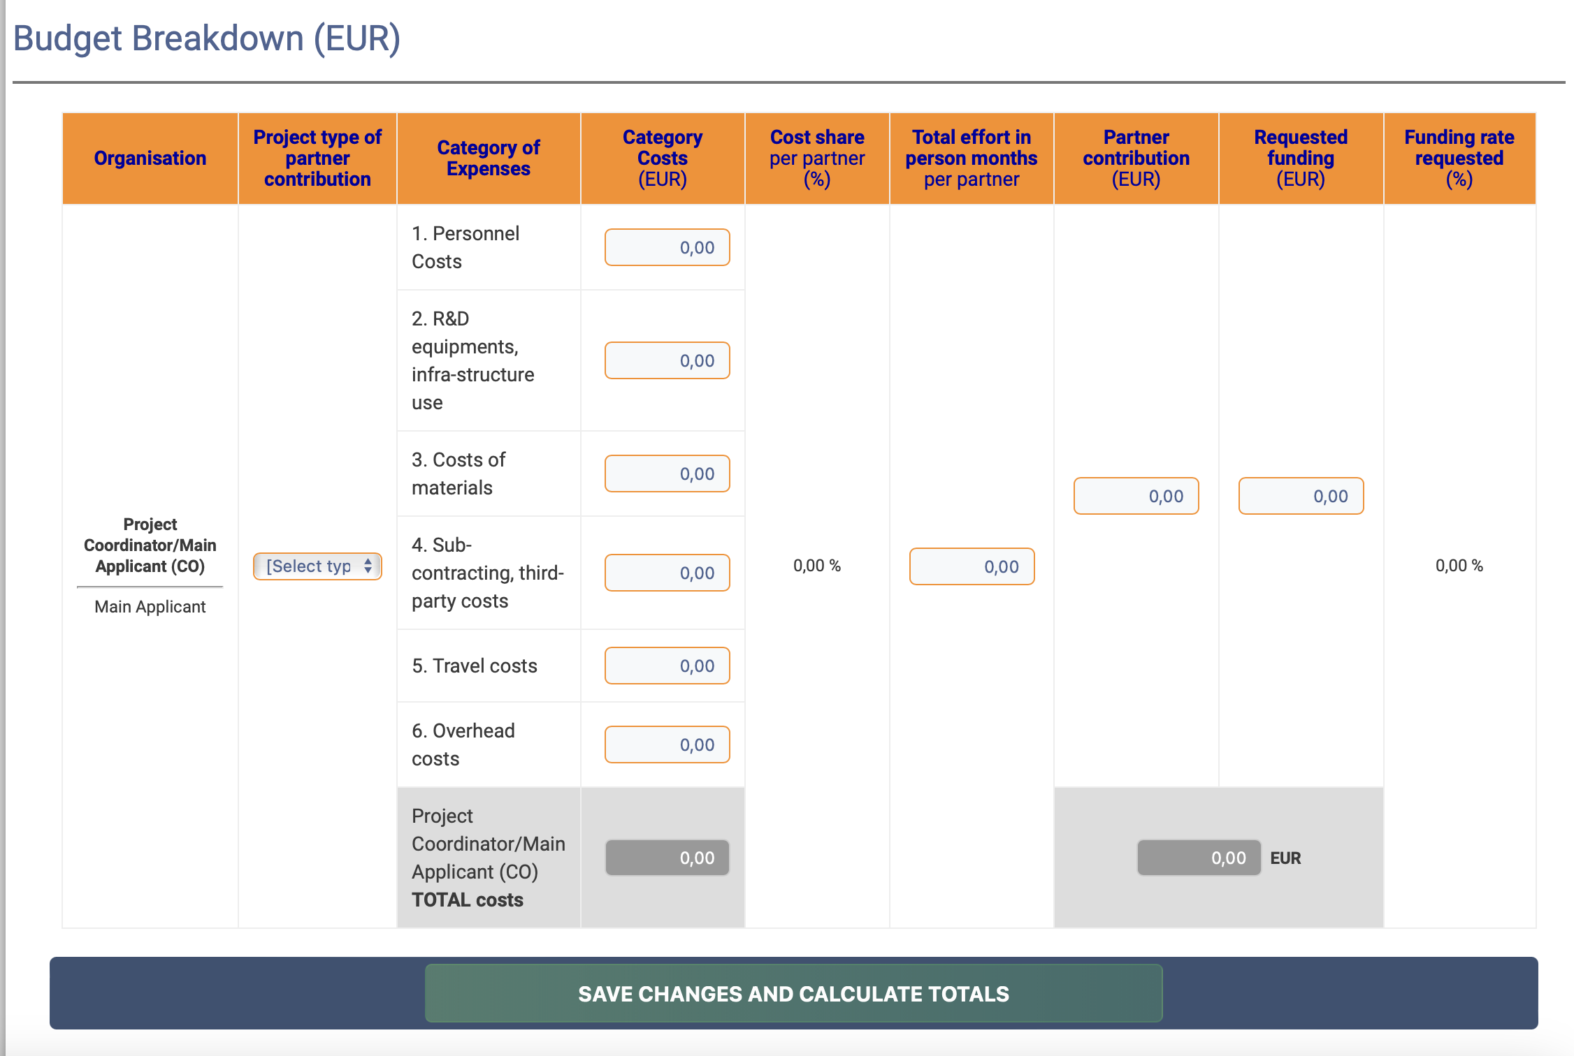

Justification of resources (max. 1 ½ pages)
Please motivate the projected costs as indicated in the Financial Information section (budget breakdown).

References (max. 2 pages)
Add relevant references.

Detailed financial information must be given in the Financial Information section on uefiscdi-direct.ro
Type of organisations: SE = small enterprise; ME = medium-sized enterprise; LE = large enterprise; RO = research organisation, OTH = other type of organization. Note: With regard to the size of companies, for all EU member states the current definitions of SMEs given in the EU competition law are applied (definition of small and medium-sized enterprises and of independent businesses in accordance with recommendation 2003/361/EC of the Commission dated 6 May 2003, [ABl. L 124 of 20.5.2003, pp. 36-41]; cf. http://ec.europa.eu/enterprise/policies/sme/files/sme_definition/ sme_user_guide_en.pdf).
Consortium partners from Belgium must name their respective funding agency/agencies.
“Project Partner” in this table means a Co-Applicant or a Co-operation Partner (see chapter 3 of the call text).
A work package is a major subdivision of the proposed project with a verifiable end point – normally a deliverable or a milestone in the overall project.
Work package number: WP 1 - WP n.
Number of the project partner leading the work in this work package.
The total number of person-months allocated to each work package.
Measured in months from the project start date (month 1).
Deliverable numbers in order of delivery dates. Please use the numbering convention <WP number>.<number of deliverable within that WP>. For example, deliverable 4.2 would be the second deliverable from work package 4.
Measured in months from the project start date (month 1).
Measured in months from the project start date (month 1)

